Computer Networks

Lab 07

4/21/2021

Nadir Hussain

023-18-0025

**Lab Objectives:**

1. Get hands on practice using DHCP protocol with global and interface method, use its commands and observe the network behavior at each step. Also use Wireshark to understand the DHCP protocol.
2. Create a network, configure telnet protocol and work with its commands.

**DHCP:**

DHCP server is preinstalled on Huawei devices i.e. router, we just need to run and configure it.

**Task1**

**DHCP global method**

**Network design**

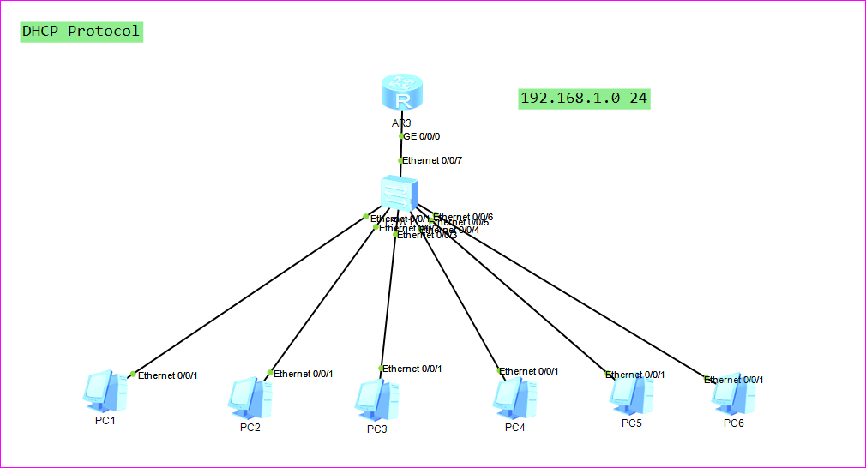

**Configure all interfaces:**

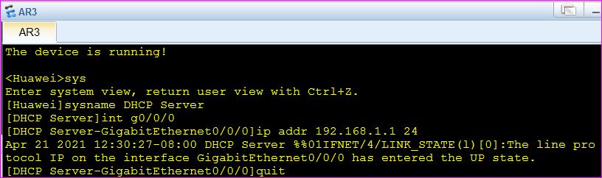

**Now use DHCP -- On router1**

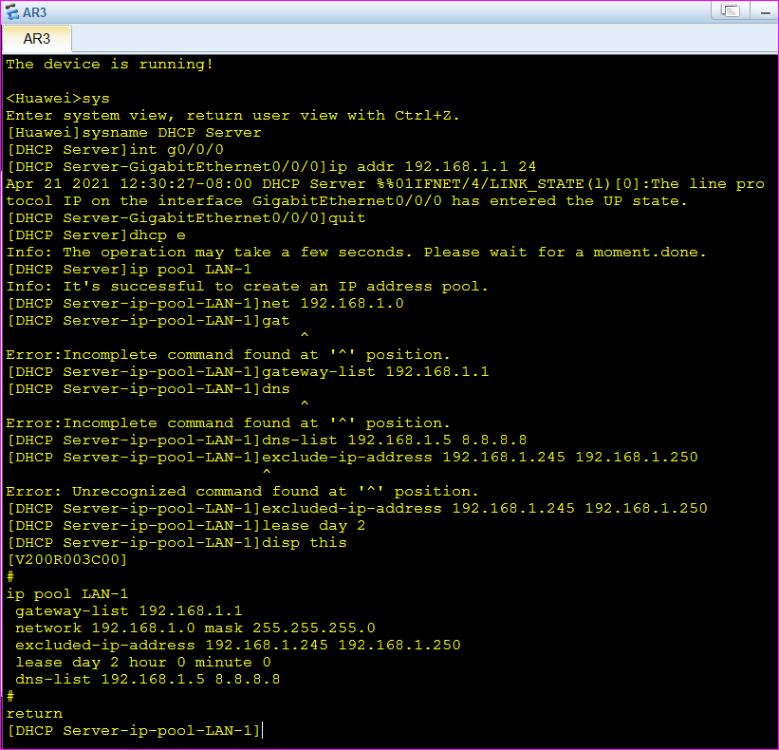

**Now we call DHCP at interfaces**

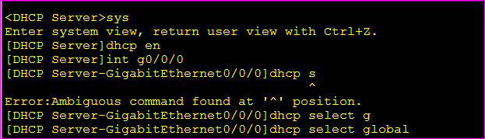

**Now DHCP is configured, let’s see the initial stats**

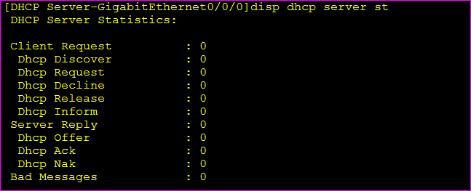

**There is no request to DHCP, No Ack or no Offer yet.**

**Now we configure all PCS by DHCP**

**Initially PCs have no IP address**

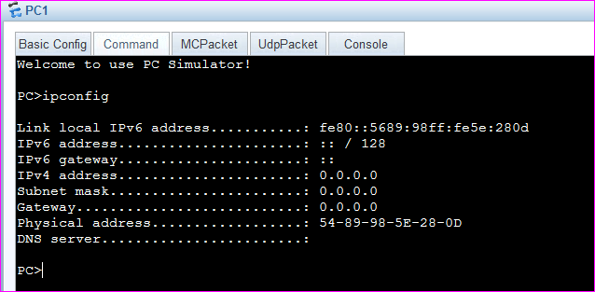

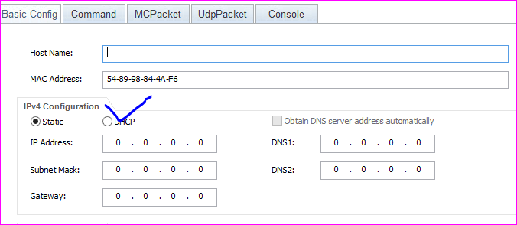

**After DHCP**

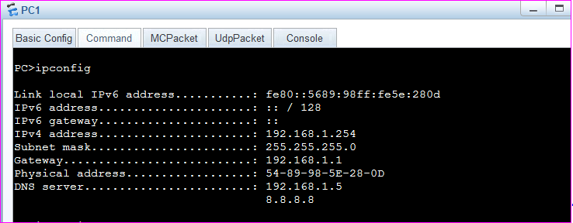

**PC2**

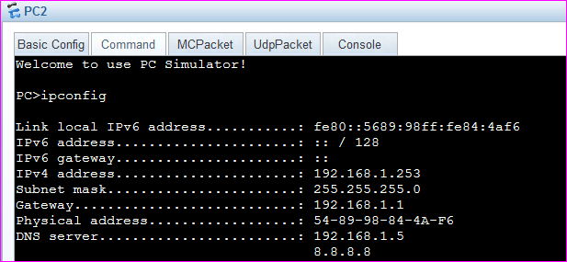

**PC3**

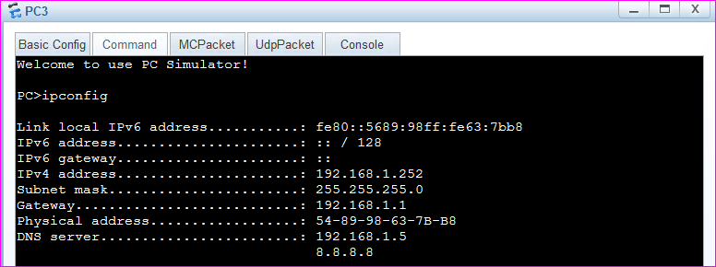

**PC4**

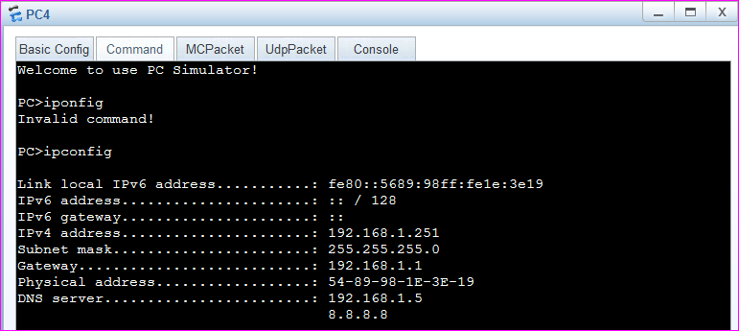

**As we have excluded IPs from 245 to 250, what Ip should be assigned next to PC5?**

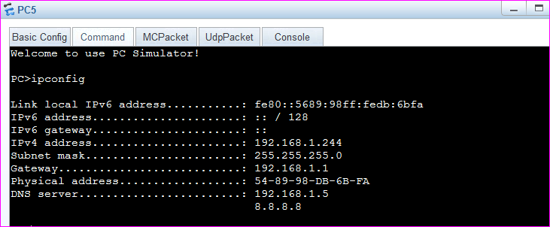

**So 244 is assigned to PC5**

**For PC6**

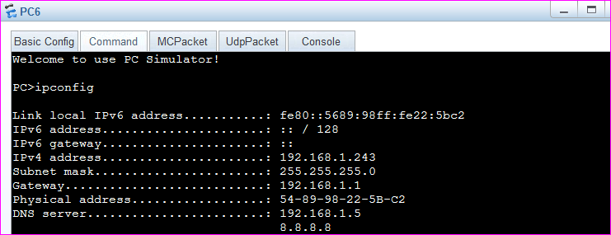

**Now the statistics on root server are.**

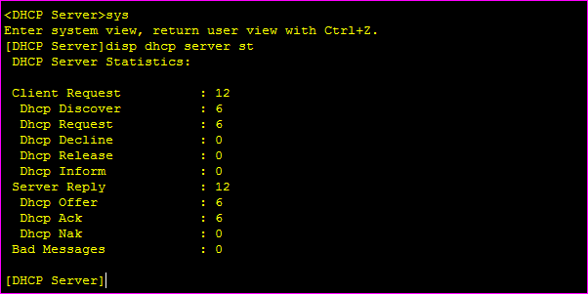

6 PCs are there, 2 requests are sent from each PC and 2 replies are returned to each PC. So there are 24 message exchanged.

Now we observe the DHCP protocol at Wireshark.

Add a new PC to network, start it. And open Wireshark on that PC.

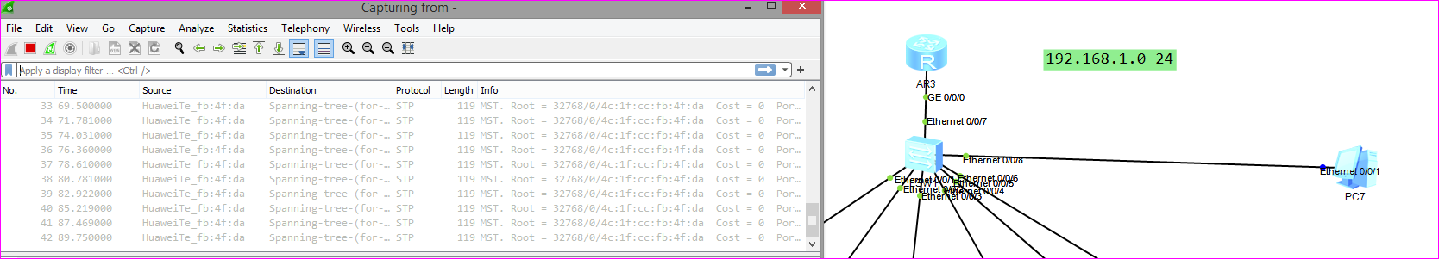

**We can’t find DHCP yet, now we configure the new PC by DHCP and observe the Wireshark again.**

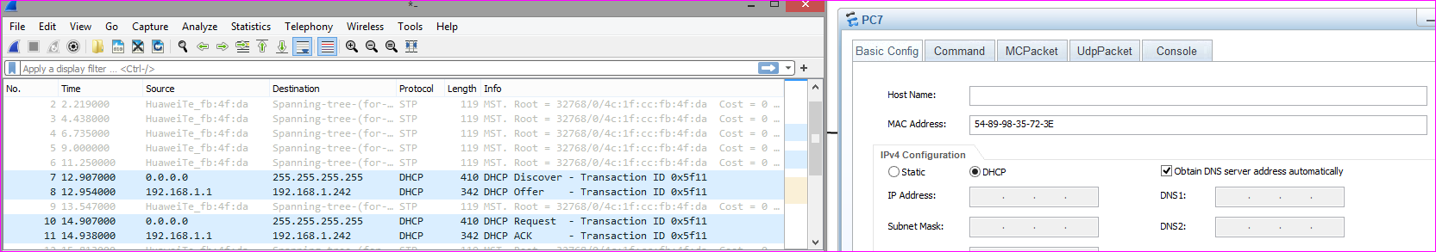

Now we find DHCP in action.

We can see 4 types of message exchanged

1. DHCP enabled, DHCP discover message was sent from client to server to get IP
2. DHCP Offers IP address to PC
3. PC requests DHCP for IP
4. DHCP server acknowledges the request and assigns IP to client

**PC7 is assigned IP**

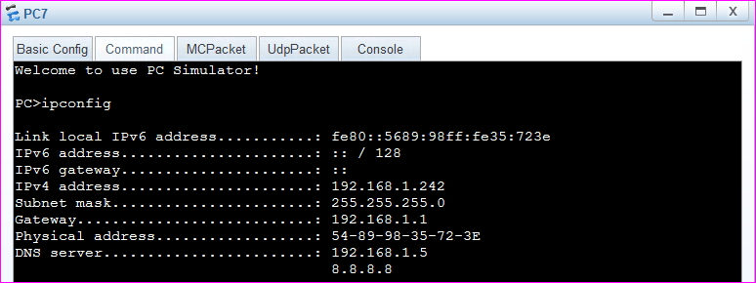

**Now we add another PC to network and undo the dhcp configuration to check if it is assigned Ip or not**

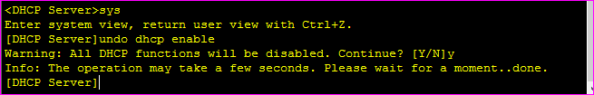

**Now we try to configure the PC by DHCP and observe the wireshark on PC9**

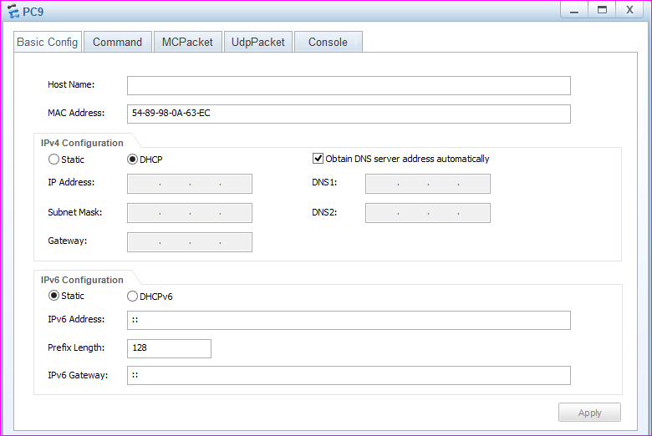

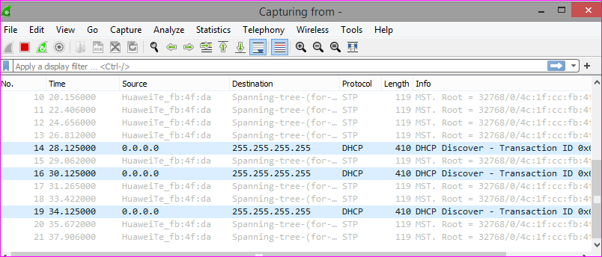

**0.0.0.0 is PC9 and it is advertising to discover the IP address for itself from DHCP, but there is no DHCP enabled.**

**DHCP Interface/local method**

**Network Design**

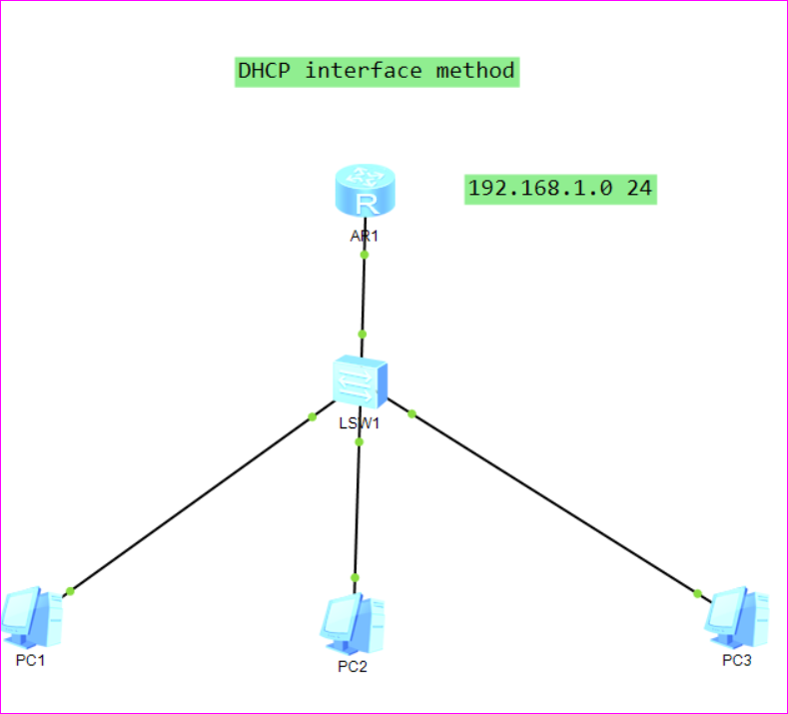

**Configure Interface**

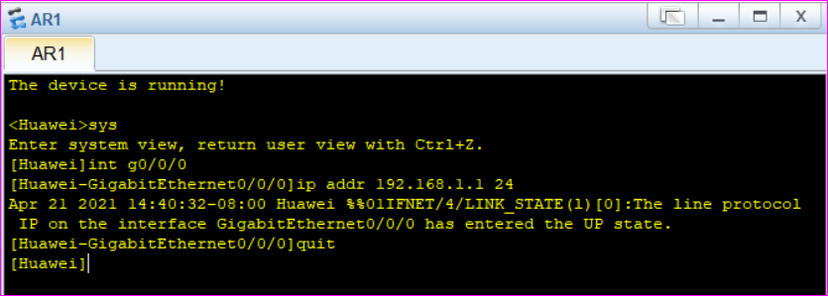

**Configure DHCP**

**We need not to create IP pool, we select dhcp select interface**

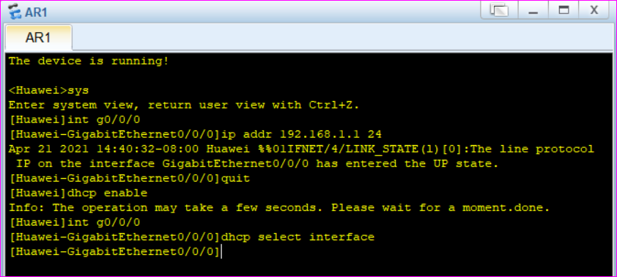

**We need not to tell the network to dhcp at interface**

**We need not to tell the gateways**

**Although we should define the dns and IPs to be excluded**

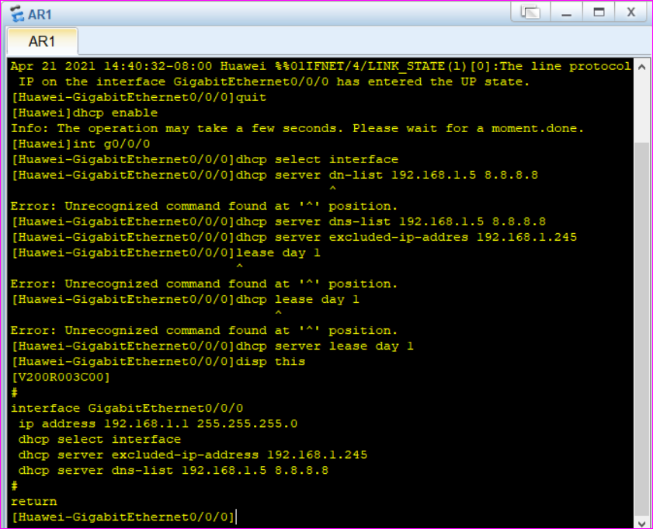

**We have excluded only one address that is 192.168.1.245**

**Note that we did not created IP pool, did not defined the gateway network selected interface this time.**

**Now we apply DHCP configuration to our PCS in network**

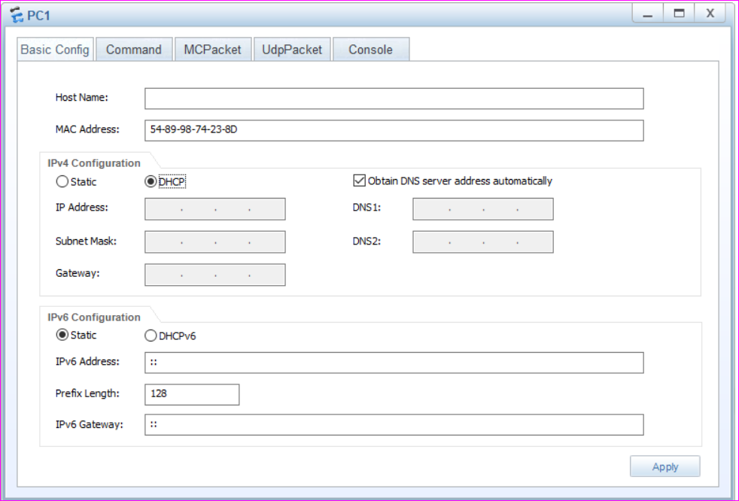

**And ip assigned is**

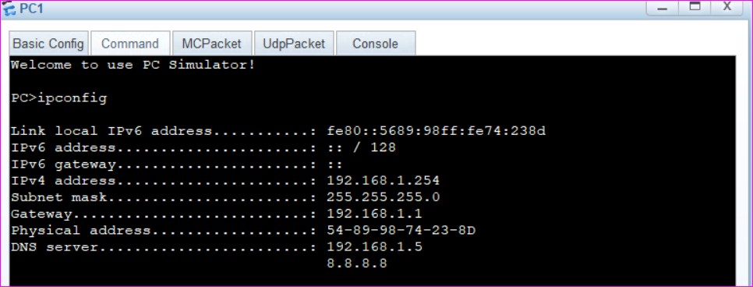

**Similarly DHCP assigns ip 192.168.1.253 and 192.168.1.252 Ips to the PC2 and PC3 respectively.**

**Telnet Protocol**

**Network design**

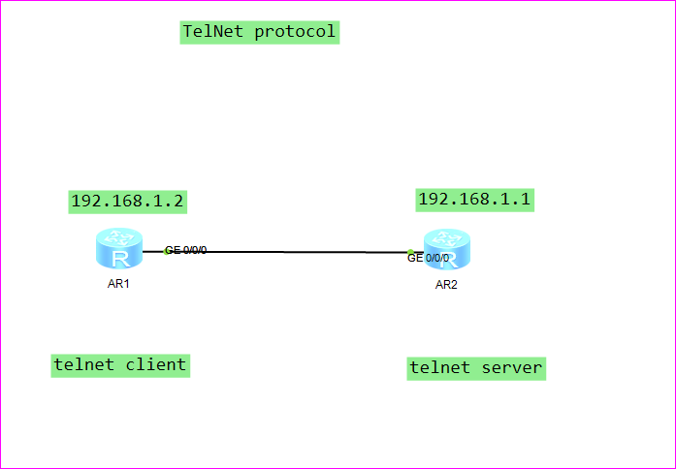

**We simply take two routers to configure telnet protocol**

**Configure interfaces**

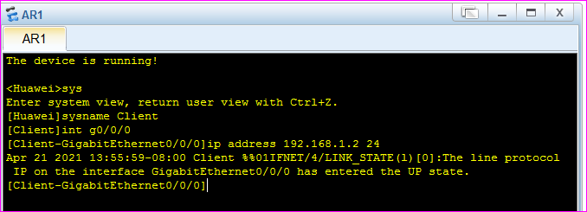

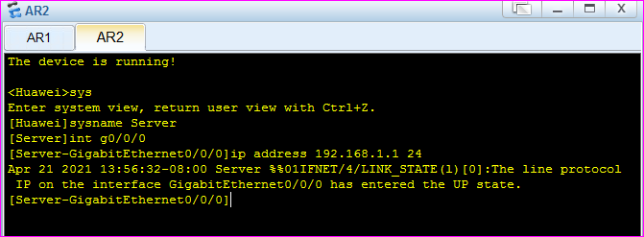

**Now we enable telnet on server**

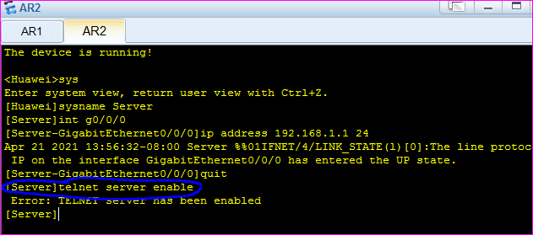

**Now we define number of users who can tele type**

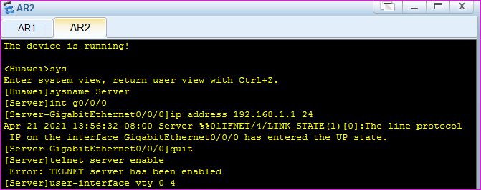

**We set password for these 4 users, with cipher encryption**

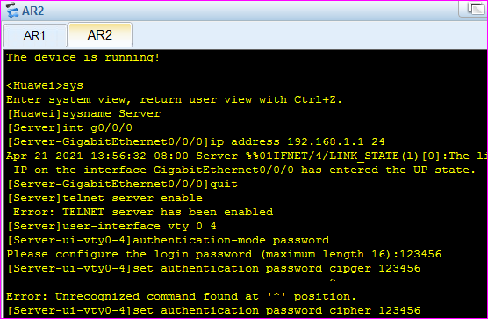

**Which protocols to be allowed on telnet remote typing**

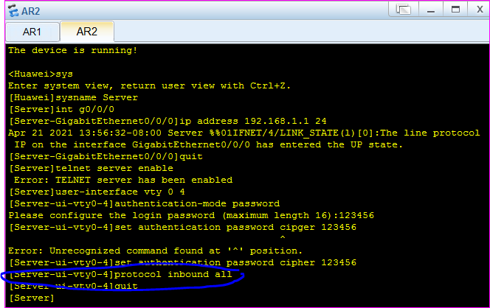

Now we have all set the Server, it can simultaneously configured by 4 uses, they will have to provide password.

On Client router, we try to connect to telnet server.

Using Server router from Client using telnet protocol

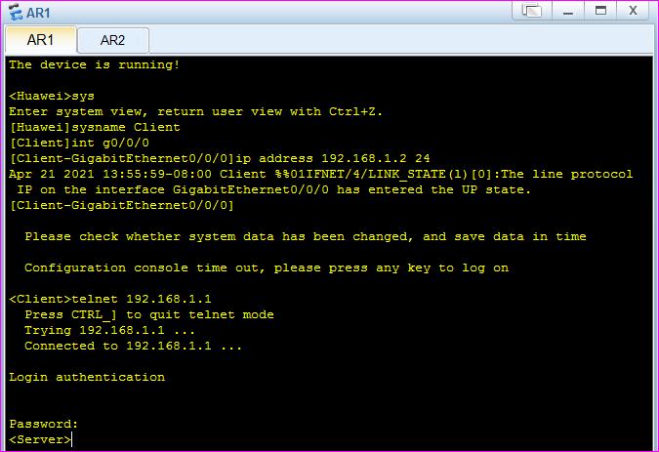

It required password to get remote access of server router.

Now we have got server prompt, that mean what we are typing will directly go to server.

telnet client will always run in user mode

**The End**